International Darth Vader

Amazon S3 User Guide

December 09th, 2016

TABLE OF CONTENTS

Introduction ……………………………………………………………………… Pg. 2

1. Logging into Amazon Web Services ……………………………………….…. Pg. 2

2. Accessing S3 and Viewing Buckets ……………………………………….….. Pg. 5

3. Manually Uploading to an S3 Bucket ………………………………………… Pg. 8

4. Downloading a file from a S3 Bucket ………………………………………… Pg. 11

5. Deleting a file from a S3 Bucket ……………………………………………… Pg. 13

6. Logging Out of Amazon Web Services ……………………………………….. Pg. 16

7. Final Notes……………………………………………………………………....Pg.17

# Introduction

The purpose of this resource is to provide instructions on using and managing the International Darth Vader product’s Amazon Web Services S3 instance. The International Darth Vader product utilizes S3’s bucket topology to synchronize audio files with the embedded system. Accessing and managing these bucket databases is done through Amazon’s website.

## 1. Logging into Amazon Web Services

This section details the process of logging into an Amazon Web Services account. Follow the numbered steps below to log in.

1. Open your preferred web browser.
2. In the address bar, type *aws.amazon.com* and press Enter to access the URL.
3. In the top-right corner of the screen, press the “Create an AWS Account” button.

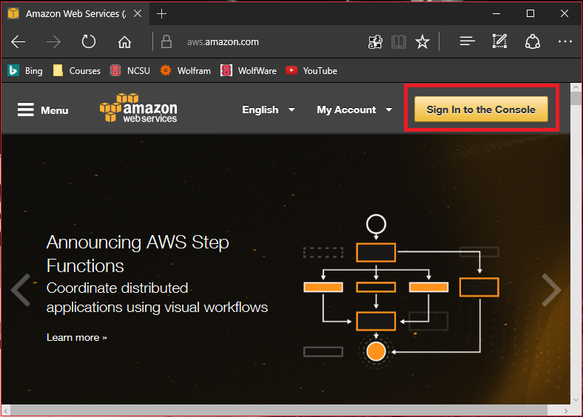

1. You should now see a screen that says “Sign In or Create an AWS Account.” Select the option that says “I am a returning user and my password is:”
2. Enter the email address and password associated with your account. Press the button that says “Sign in using our secure server” to log into your account.
   1. If you need help accessing your account, select the “Forgot your password?” option below the “Sign in using our secure server” button and follow the instructions.

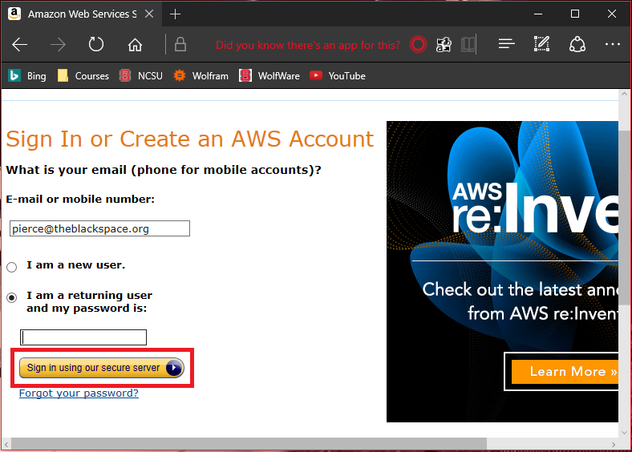

1. You should now be logged into Amazon Web Services and should see a page that says AWS services. OB.PNG
   1. You may get back to this page at anytime while on the Amazon Web Services site by clicking the orange box icon in the top-left corner of the screen.

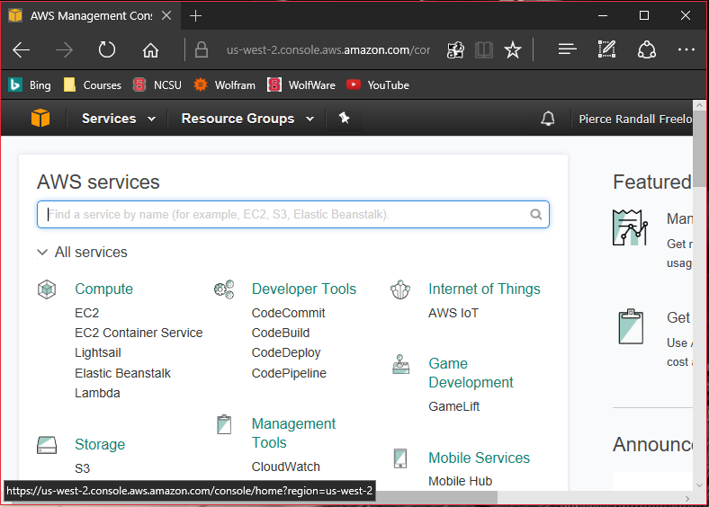

## 2. Accessing S3 and Viewing Buckets

This section details the process of accessing the S3 service once already logged into Amazon Web Services. Follow the numbered steps below to access S3 and view different buckets.

1. From the AWS services page, scroll down until you see the **Storage** heading on page. For instructions on getting to the AWS services, see Section 1: *Logging into Amazon Web Services.*

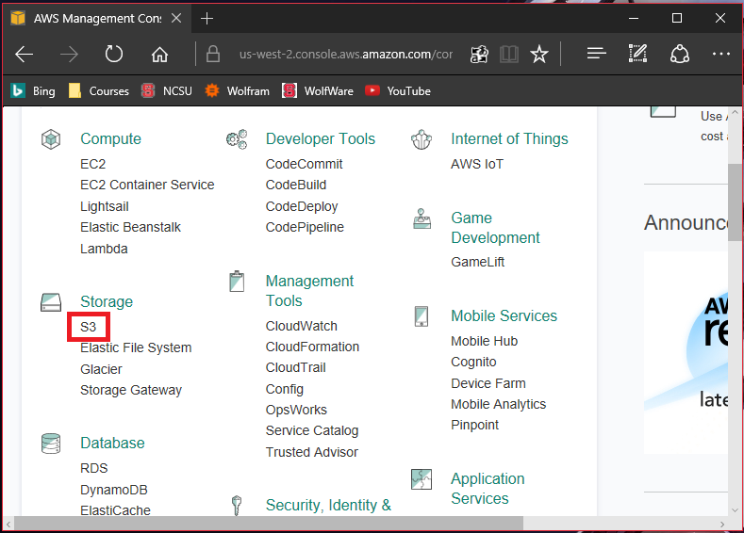

1. Click the link that says “S3” below the **Storage** heading.

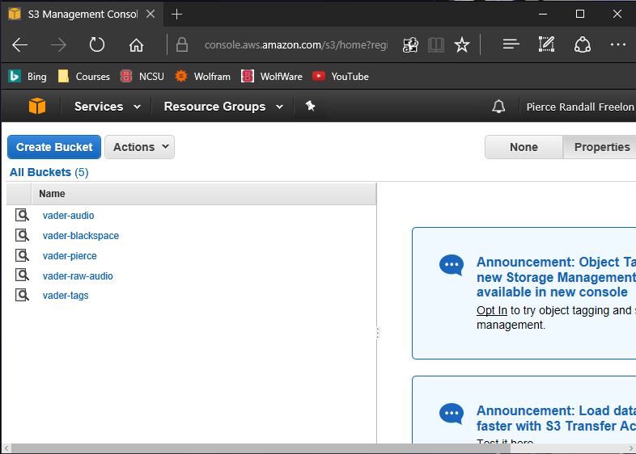

1. You should now see a list of all available buckets under the account. Click the title of a bucket to view it’s contents.
   1. For the International Darth Vader product, raw audio data is uploaded to the *vader-raw-audio* bucket. Automated lambda functions1 convert the audio from M4A to MP3. The audio is then moved to both the *vader-blackspace* bucket and the *vader-tags* bucket. Audio data in the *vader-tags* bucket is organized by tag where folder names share the audio tags.

[1]

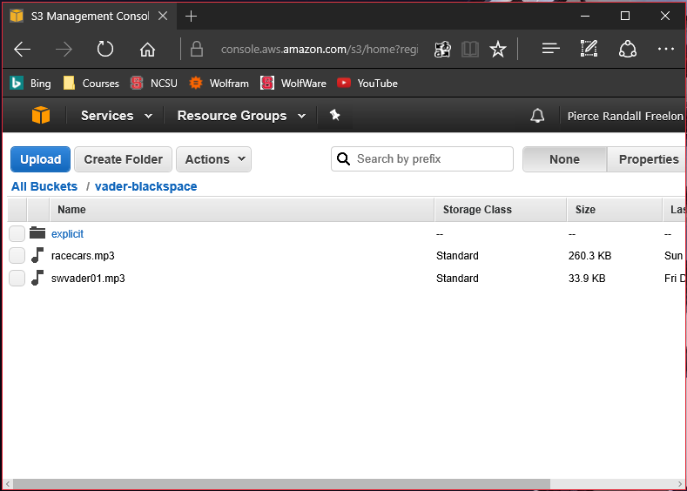

## 3. Manually Uploading to an S3 Bucket

This section details the process of uploading files manually to a S3 bucket once already logged into Amazon Web Services. Follow the numbered steps below to access S3 and view different buckets.

1. From the available buckets page, select the bucket to which you would like to upload a file. For instructions on getting to the available buckets page, see Section 2: *Accessing S3 and Viewing Buckets.* For this tutorial, we will be using the *vader-blackspace* bucket.
2. Once in the *vader-blackspace* bucket, select the blue “Upload” button towards the top-left corner of the screen.

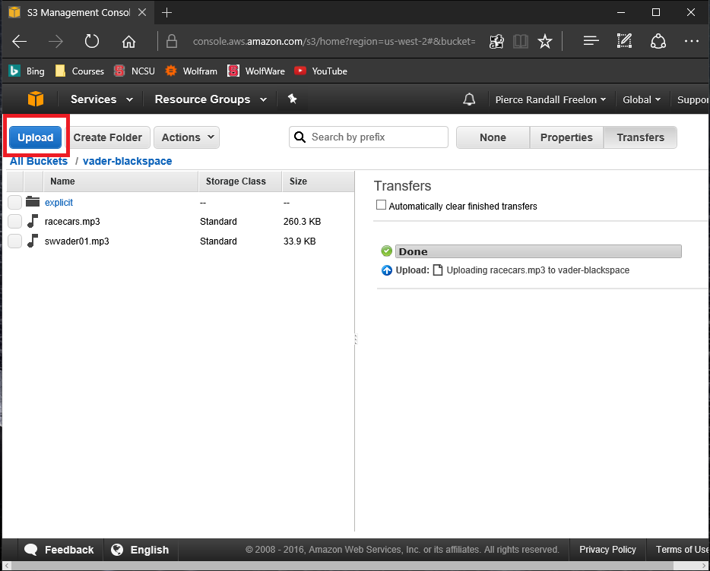

1. In the upload context menu, select the “Add Files” option signified by a green plus icon. gp.PNG
2. Select a file from the popup file selection menu and open the file. The file should appear in the upload context menu in a list format. Multiple files may be uploaded at once.
3. Click “Start Upload” in the bottom-right hand corner of the screen.

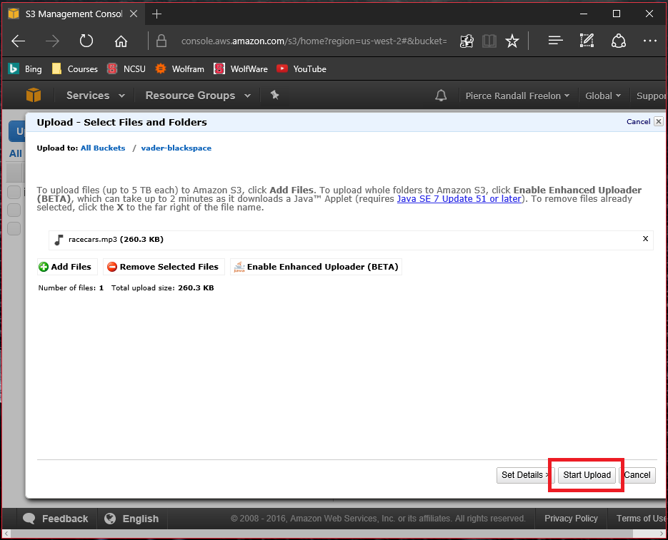

1. A “Transfers” side-menu will appear showing the progress of the upload. The upload bar will say “Done” when the upload has completed. Please note that the International Darth Vader product will only be able to synchronize and use the .MP3 file format.

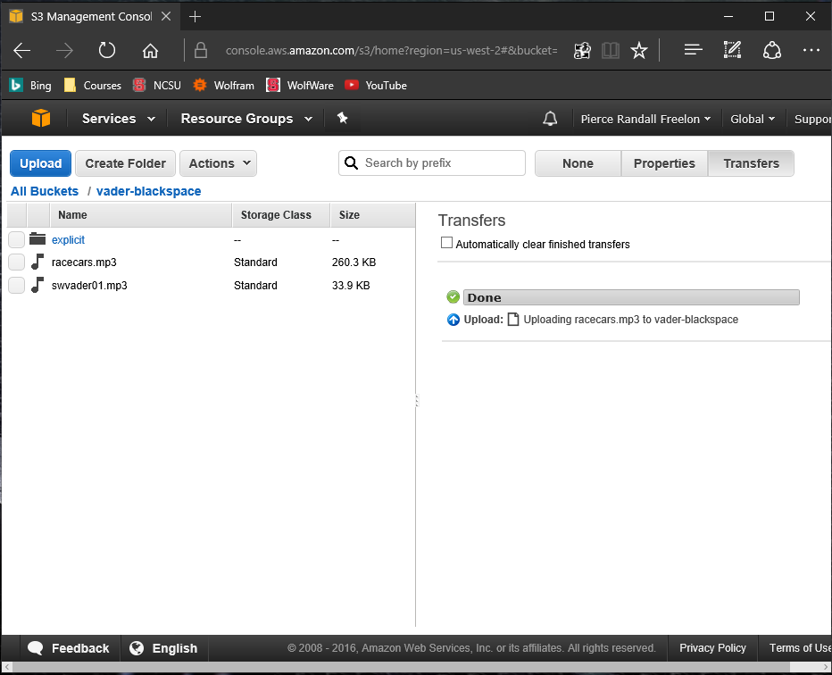

## 4. Downloading a file from a S3 Bucket

This section details the process of downloading files from a S3 bucket once already logged into Amazon Web Services. Follow the numbered steps below to access S3 and view different buckets.

1. From the available buckets page, select the bucket to which you would like to upload a file. For instructions on getting to the available buckets page, see Section 2: *Accessing S3 and Viewing Buckets.* For this tutorial, we will be using the *vader-blackspace* bucket.
2. Once in the *vader-blackspace* bucket, select the file you would like to download.
3. Right-click on the file you would like to download to review a context menu. Select the download option.

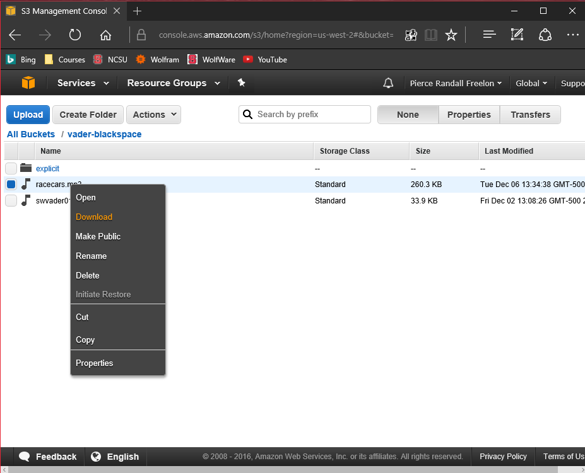

1. A menu will appear prompting to “right-click the download link below and choose ‘Save Link As…’” Right-click the download link and select the “Save Link As…” option.

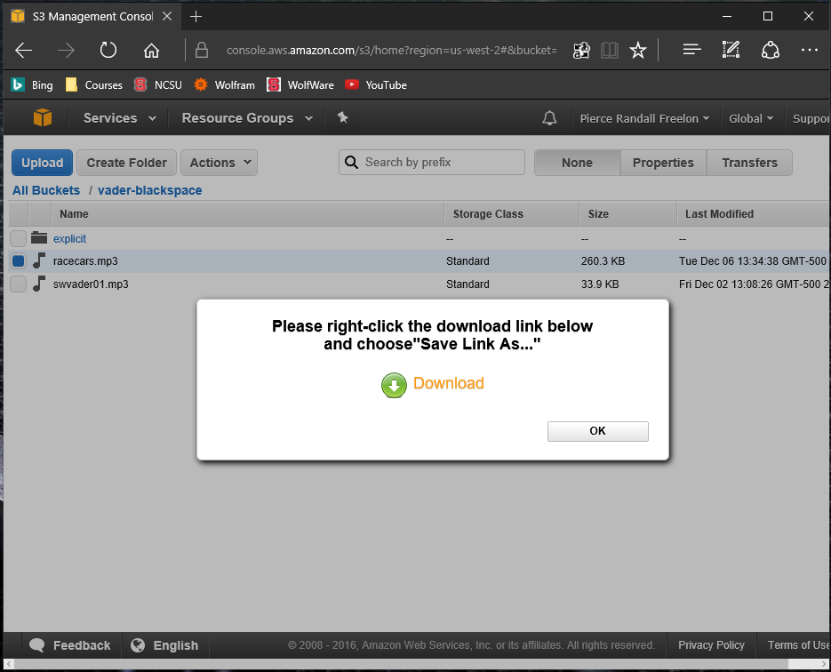

1. Follow your web browser’s instructions to save the file. Once the download completes, the file should be available on your local machine.

## 5. Deleting a file from a S3 Bucket

This section details the process of deleting files from a S3 bucket once already logged into Amazon Web Services. Follow the numbered steps below to access S3 and view different buckets.

1. From the available buckets page, select the bucket to which you would like to upload a file. For instructions on getting to the available buckets page, see Section 2: *Accessing S3 and Viewing Buckets.* For this tutorial, we will be using the *vader-blackspace* bucket.
2. Once in the *vader-blackspace* bucket, select the file you would like to delete.
3. Right-click on the file you would like to delete to review a context menu. Select the delete option.

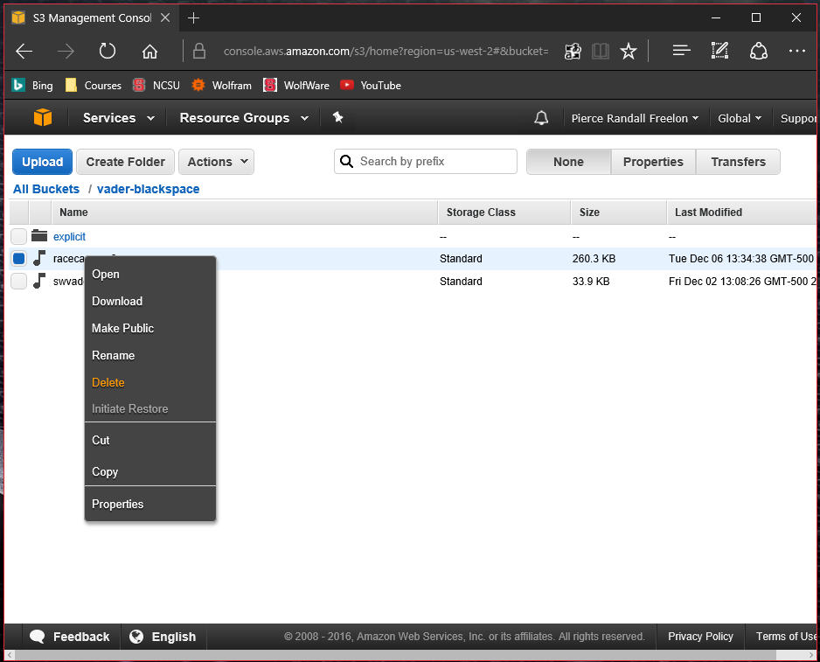

1. Your web browser will prompt you with a dialog box asking “Are you sure you want to delete *filename.extension*?” Select “Ok” if you would like to delete the file. This will also remove the file from any International Darth Vader product that is synchronized with the bucket.

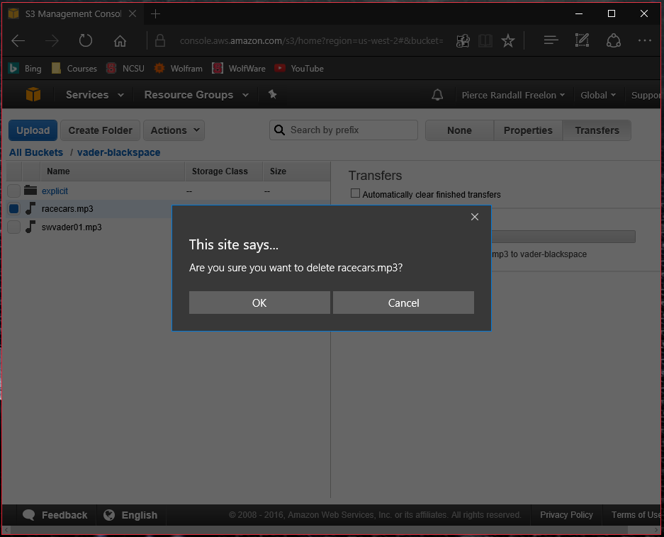

1. A “Transfers” side-menu will appear showing the removal progress. The status bar will say “Done” when the deletion has completed.

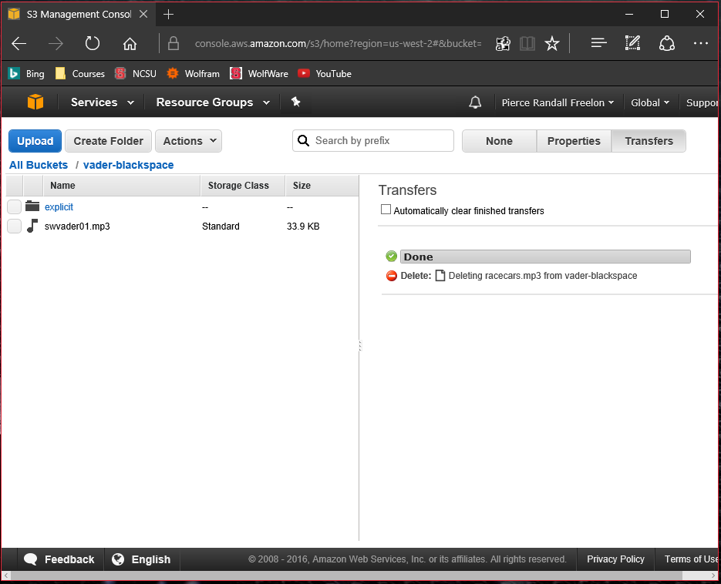

## 6. Logging Out of Amazon Web Services

This section details the process of logging out of an Amazon Web Services account. Follow the numbered steps below to log in.

1. On any Amazon Web Services page while logged into an account, find the owner of the account’s name in the top right-hand corner of the screen.
2. Click the name to reveal a drop-down context menu.
3. Select the option that says “Sign Out” at the bottom of the drop-down menu.

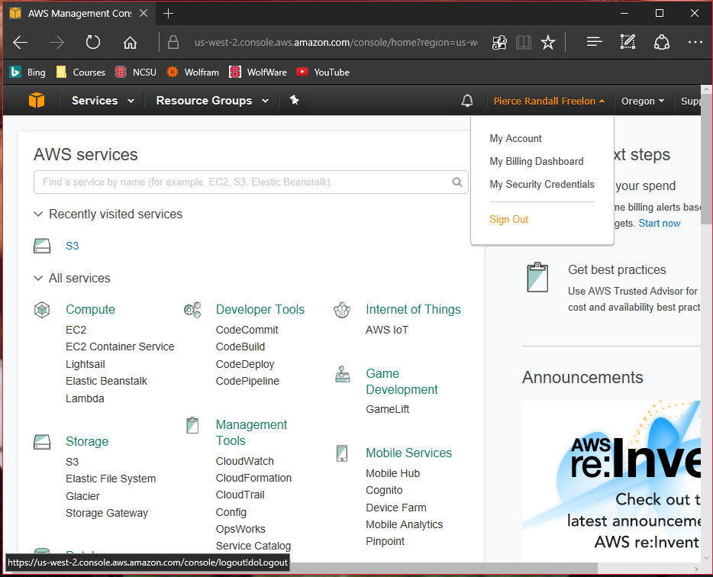

1. You will be redirected to the AWS Management Console page with an option to “Sign in to the Console. You have successfully logged out of your Amazon Web Services account.’

## 7. Final Notes

Amazon Simple Storage Service (S3) is fairly intuitive. Amazon has provided a thorough documentation as well that can be found [here](http://docs.aws.amazon.com/AmazonS3/latest/gsg/GetStartedWithS3.html). This guide should provide any additional insight should more information be necessary. Within their documentation they provide guidance on all of their functionalities, some of which are not needed for the International Darth Vader.

For any additional concerns, you may investigate the Amazon Web Services support options on the Amazon website. The website link may be found below.

<https://aws.amazon.com/premiumsupport/>

1. AWS Lambda lets you run code without provisioning or managing servers. With Lambda, you can run code for virtually any type of application or backend service - all with zero administration.